|  |  |
| --- | --- |
| Project Name: | HRAS |
| Test Case Number: | 1 |
| Brief description: | Testing for user type validation |
| Relevant section of spec doc: | Section 3.1 |

Input Assumptions:

Relevant state of DB: “INSERT INTO [User](Username, Password, UserType) VALUES('jimbob', '123', '1')”

User Actions:

1. Open Microsoft SQL Server Management Studio
2. Connect to the database
3. Open the drop-down list for the database
4. Open the drop-down list for programmability
5. Ensure the stored procedure is in the list name ‘validateUserType’
6. Right click the procedure
7. Click ‘Execute stored procedure….’
8. Type in the value column ‘jimbob’
9. Click okay
10. Click execute

Expected Results:

The expected result is 1

Actual Result:

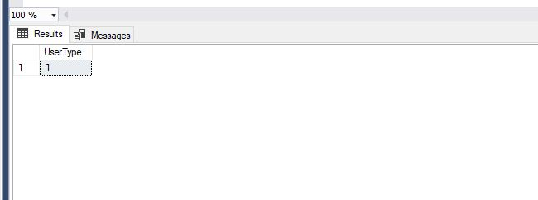

Result matches expected result? Yes  No

If not then, fill out the information below:

|  |  |
| --- | --- |
| Defect Report Number: |  |
| Assigned to: |  |